**CS590BD Big Data Analytics and applications**

**LAB1 Assignment**

* **Task 1:**Apps with Mobile devices ans sensors
  + Task1.1 : T1 sensor Tag with android sensor app

Steps: a) Imported projected into workspace.

b)run the application as Android application.

c) following output produced.

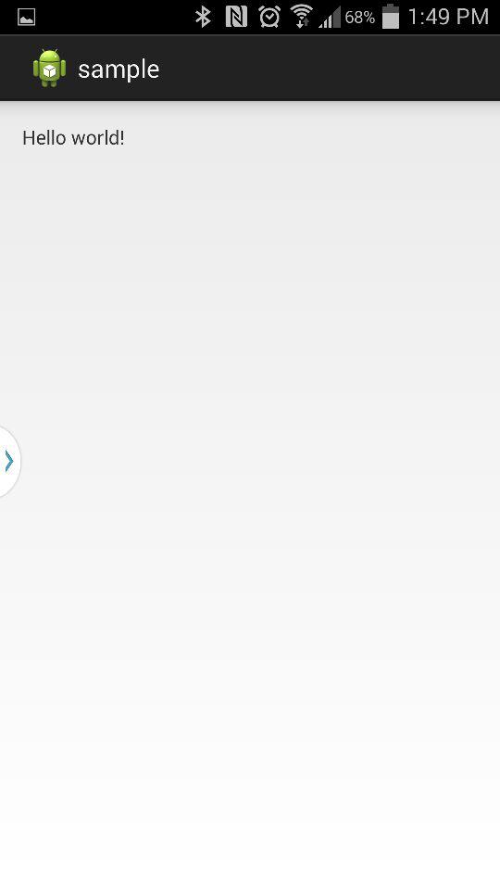

*Logcat view*

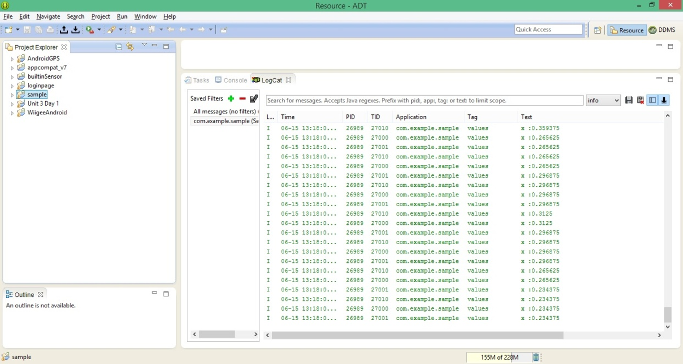

X coordinate value changes ,when you change the sensor location.

* Task 1.2: Mobile sensor with Android sensor app

Steps:a) run your application as android application.

b)following output will be produced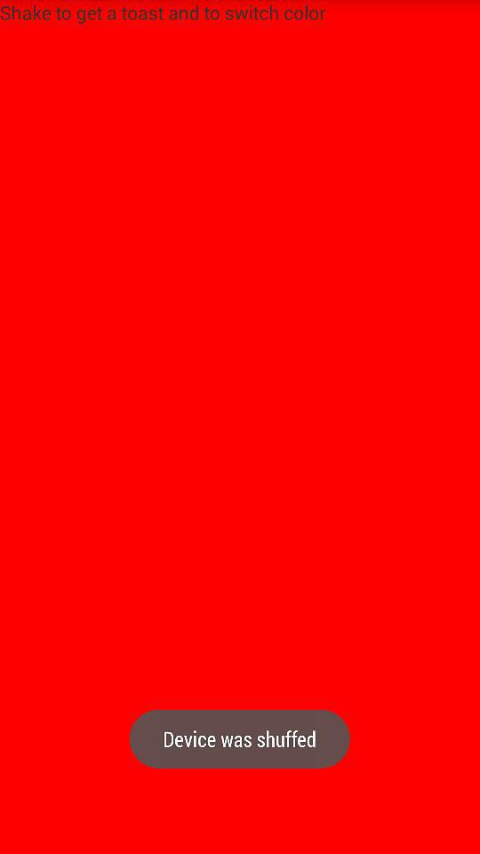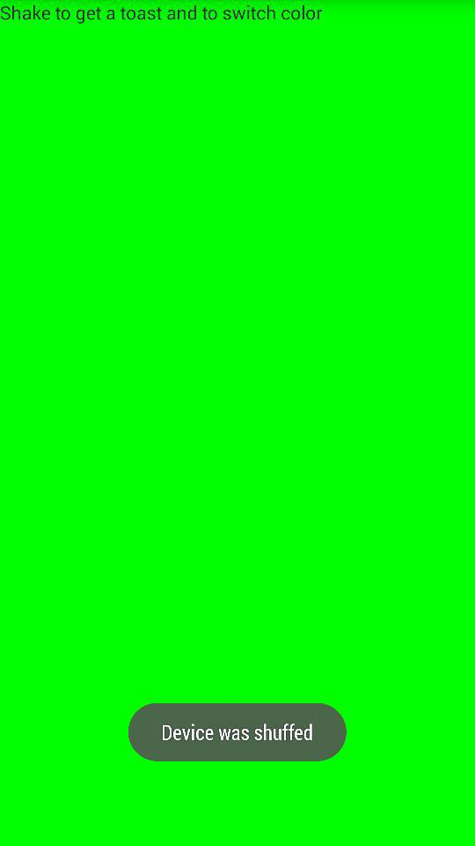

* Task1.3: GPS feature with Android smart phone

Steps: a) run your application as android application.

b)following output will be produced

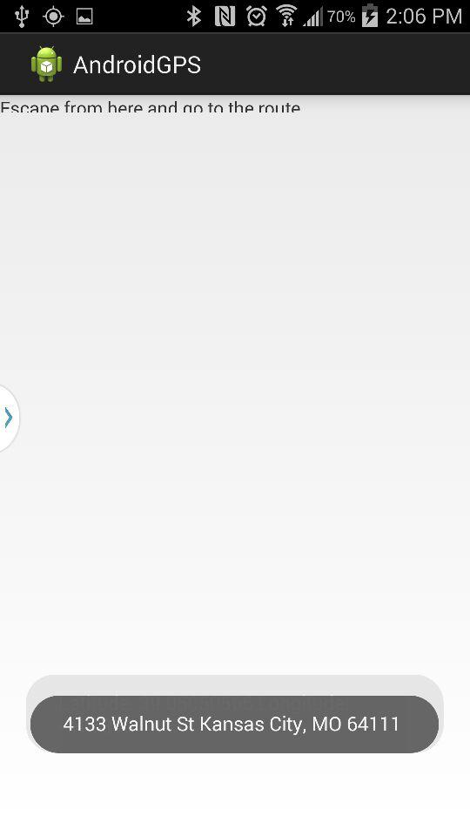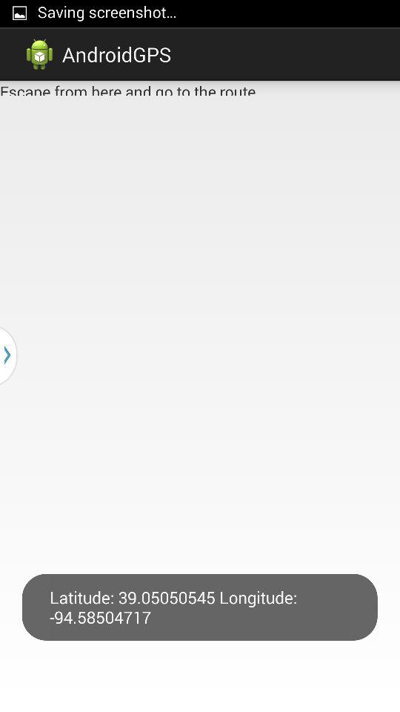

* Task 1.4: Wiigee app with Android smart phone.

Steps: a) run your application as android application.

b)following output will be produced

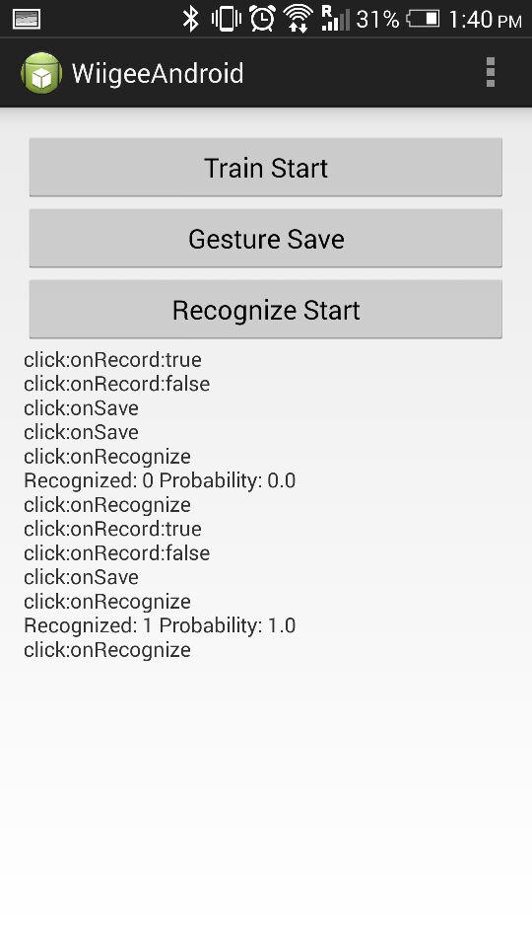

* Task1.5: T1 chronos watch with java app

Steps: a)Install the control center from CD,click start access point

b)following output will be produced

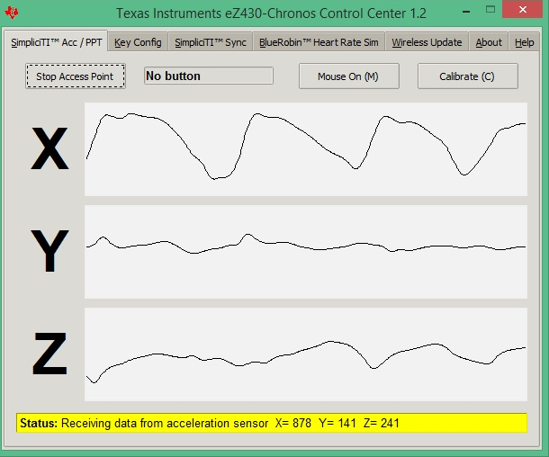

Demo for punchmeter game

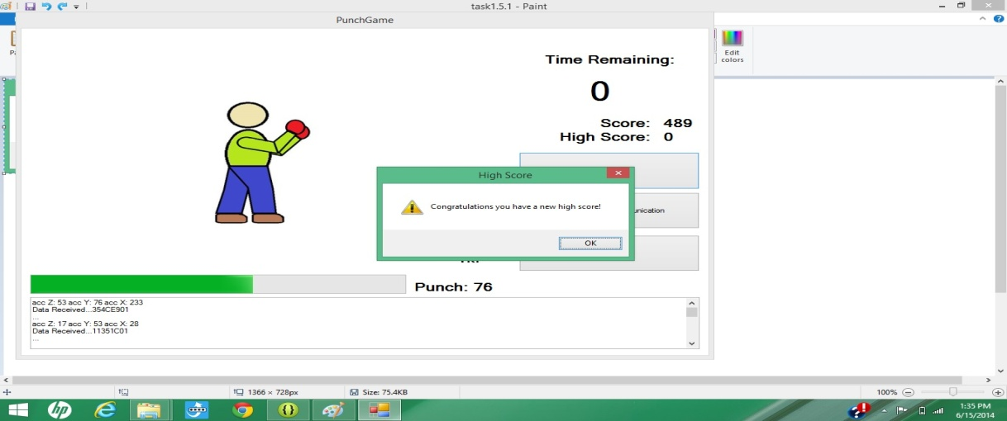

* **Task 2: Cloudera**
* Task 1: Access UMKC cloudera servers

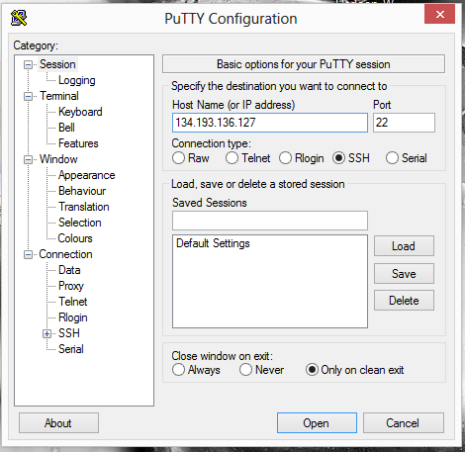

* Task 2.1: How to install your own cloudera server

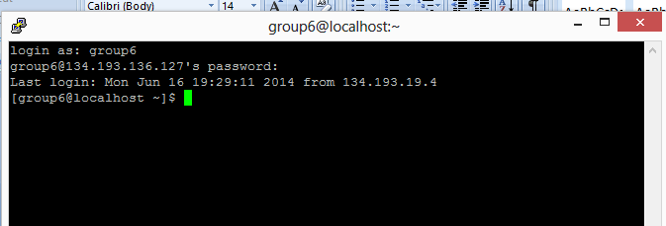

* Task 2.3 How to transfer files to cloudera{**using Winscp**}

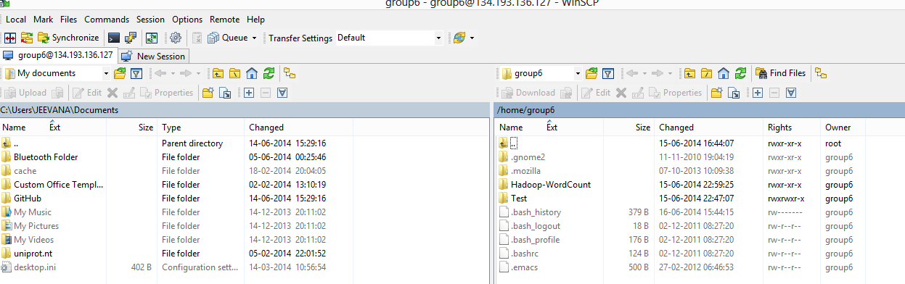

* Task 2.4 Run word count on cloudera

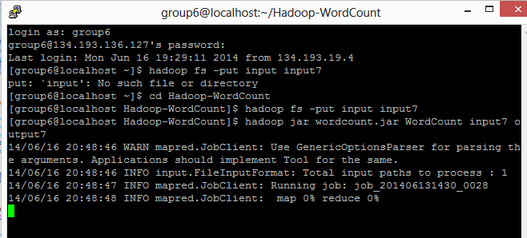

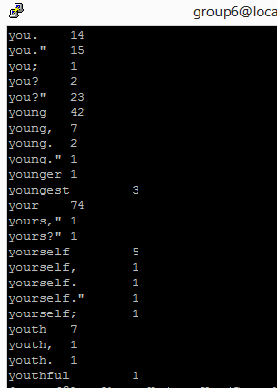

* **Task 3: GitHub and Scrumdo**

